1-Mavzu: “Sun’iy intellekt asoslari” faniga kirish va asosiy tushunchalari.
11-mashg‘ulot. Pythonda Funksiyaga doir dasturlar tuzish.
O‘quv savollari:
1. Funksiyalarni aniqlash va uni chaqirishni o‘rganish.
2. Parametrli va parametrsiz funksiyalarga doir dastur tuzish.

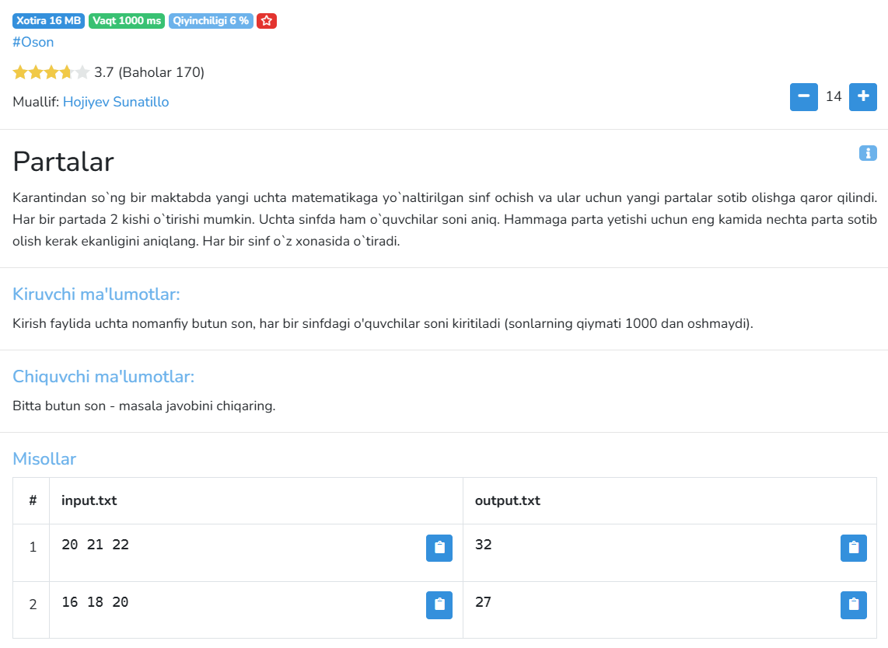
def func(x):
return (x + 1) // 2

a, b, c = map(int, input().split())
print(func(a) + func(b) + func(c))

def func(a, b, c):
return (a + 1) // 2 + (b + 1) // 2 + (c + 1) // 2

a, b, c = map(int, input().split())
print(func(a, b, c))

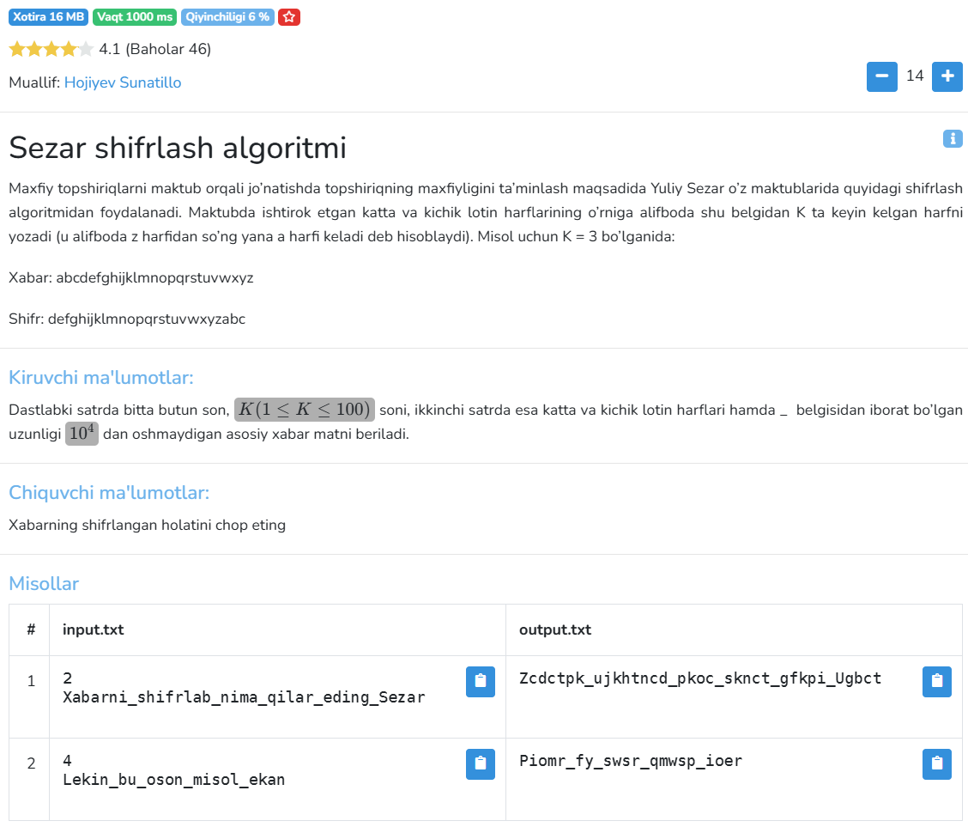

def sezar(k, s):
temp1 = "abcdefghijklmnopqrstuvwxyzabcdefghijklmnopqrstuvwxyz"
temp2 = "ABCDEFGHIJKLMNOPQRSTUVWXYZABCDEFGHIJKLMNOPQRSTUVWXYZ"
k %= 26
result = ""
for c in s:
ind1 = temp1.find(c)
ind2 = temp2.find(c)
if(ind1 != -1):
result += temp1[ind1 + k]
elif(ind2 != -1):
result += temp2[ind2 + k]
else:
result += c
print(result)

k = int(input())
s = input()
sezar(k, s)

def caesar_cipher(text: str, k: int) -> str:
"""Sezar shifrlash algoritmi.
text - matn
k - siljitish soni
"""
result = []
k = k % 26 # 26 harfli alifboda ortiqcha aylanishni kamaytirish

for ch in text:
if 'a' <= ch <= 'z': # kichik harf
new_char = chr((ord(ch) - ord('a') + k) % 26 + ord('a'))
result.append(new_char)
elif 'A' <= ch <= 'Z': # katta harf
new_char = chr((ord(ch) - ord('A') + k) % 26 + ord('A'))
result.append(new_char)
else:
# boshqa belgilar (masalan "_") o'zgarmaydi
result.append(ch)

return "".join(result)

# Asosiy qism
if __name__ == "__main__":
import sys
data = sys.stdin.read().splitlines()
k = int(data[0])
text = data[1]
print(caesar_cipher(text, k))

1. if __name__ == "__main__":
- Har bir Python faylida yashirin o‘zgaruvchi __name__ bo‘ladi.
- Agar faylni asosiy dastur sifatida ishga tushirsak, __name__ ning qiymati "__main__" bo‘ladi.
- Agar faylni boshqa joyda import qilsak, unda __name__ qiymati o‘sha modulning nomi bo‘ladi.
Shu sababli:
if __name__ == "__main__":
qatori faqat faylni to‘g‘ridan-to‘g‘ri ishga tushirganda ichidagi kod bajarilishini ta’minlaydi. Import qilinganda esa bu qism ishlamaydi.

2. import sys
- sys — Python standart kutubxonasi moduli.
- U yordamida Python interpreteri va tizim bilan ishlash mumkin (sys.argv, sys.stdin, sys.exit, va h.k.).

3. data = sys.stdin.read().splitlines()
- sys.stdin.read() → bu kirish oqimini (input stream) to‘liq o‘qiydi. Ya’ni foydalanuvchi yoki fayldan berilgan barcha matnni satr sifatida oladi.
- .splitlines() → o‘qilgan uzun matnni qatorlarga bo‘lib, ro‘yxat (list) qilib qaytaradi.
Masalan:
Kirish:
2
Hello
data = sys.stdin.read().splitlines()
print(data)
Natija:
['2', 'Hello']

new_char = chr((ord(ch) - ord('a') + k) % 26 + ord('a'))

bu nima degani?

1. ord(ch)
- ord() funksiyasi belgining Unicode/ASCII kodini qaytaradi.
- Masalan:
ord('a') # 97
ord('b') # 98
ord('z') # 122

2. ord(ch) - ord('a')
- Bu orqali harfni 0 dan 25 gacha indeksga aylantiramiz.
- Masalan:
  - 'a' → 97 - 97 = 0
  - 'b' → 98 - 97 = 1
  - 'z' → 122 - 97 = 25

3. + k
- Shifrda berilgan siljitish sonini qo‘shamiz.
- Masalan: 'a' ni 3 ga siljitsak → 0 + 3 = 3.

4. % 26
- Harflar soni 26 ta. % 26 orqali aylanishni ta’minlaymiz.
- Masalan: 'z' (25) ni 3 ga siljitsak → 25 + 3 = 28,
28 % 26 = 2 → bu 'c' bo‘ladi.

5. + ord('a')
- Indeksni qaytadan Unicode kodiga aylantiramiz.
- Masalan: 3 + 97 = 100 → bu 'd'.

6. chr(...)
- chr() funksiyasi raqamni qayta belgi (harf)ga o‘giradi.
- Masalan: chr(100) → 'd'.
Natijada:
Agar ch = 'a' va k = 3 bo‘lsa:
ord('a') - ord('a') = 0
0 + 3 = 3
3 % 26 = 3
3 + 97 = 100
chr(100) = 'd'
'a' → 'd'

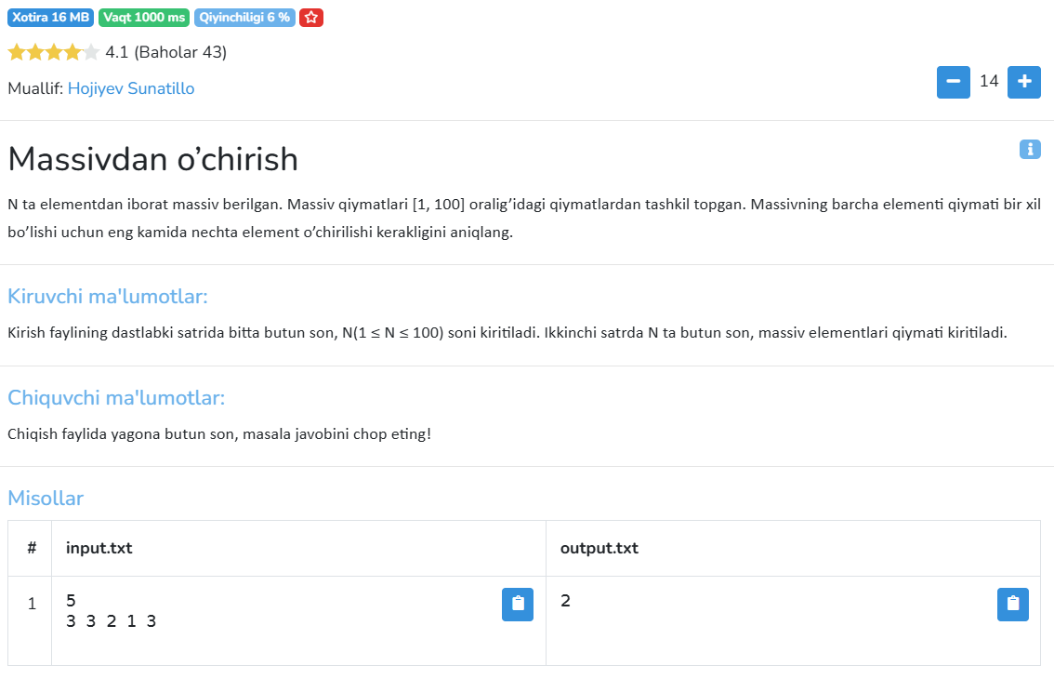
def func(n, arr):
temp = [0]*101
for val in arr:
temp[val] += 1
mx = max(temp)
return n - mx

n = int(input())
arr = list(map(int, input().split()))
res = func(n, arr)
print(res)

def min_deletions_to_equalize(arr):
from collections import Counter
freq = Counter(arr) # har bir elementning chastotasi
max_freq = max(freq.values()) # eng ko‘p uchragan element soni
return len(arr) - max_freq

if __name__ == "__main__":
import sys
data = sys.stdin.read().split()
n = int(data[0])
arr = list(map(int, data[1:]))
print(min_deletions_to_equalize(arr))

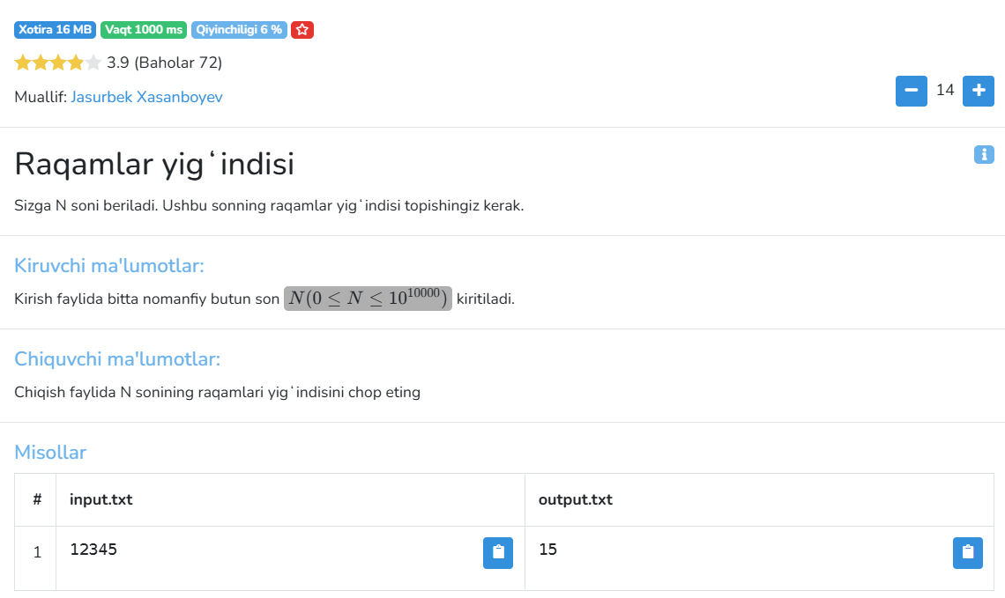
def sumDigits(n):
return sum(int(digit) for digit in n)

n = input()
print(sumDigits(n))

def digit_sum_recursive(n: int) -> int:
"""Raqamlar yig'indisini rekursiv hisoblaydi."""
if n < 10: # bitta raqam qolsa
return n
return n % 10 + digit_sum_recursive(n // 10)

if __name__ == "__main__":
import sys
data = sys.stdin.read().strip()
n = int(data) # bu safar int qilib ishlatyapmiz
print(digit_sum_recursive(n))

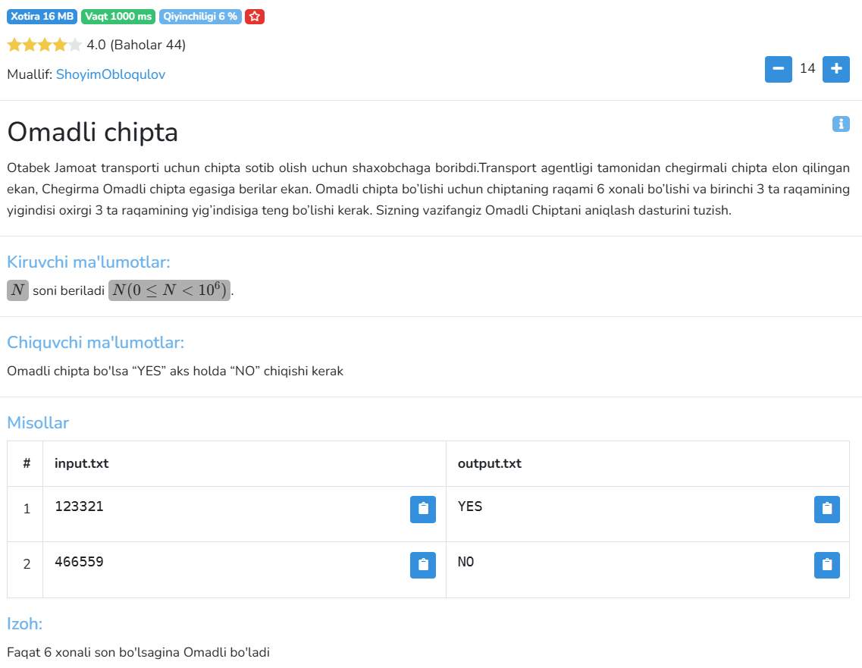

def func(n:str):
if len(n) != 6:
print("NO")
elif int(n[0]) + int(n[1]) + int(n[2]) == int(n[3]) + int(n[4]) + int(n[5]):
print("YES")
else:
print("NO")

n = input()
func(n)

def is_lucky_ticket(n: int) -> str:
s = str(n)
if len(s) != 6: # faqat 6 xonali son bo‘lishi kerak
return "NO"
left = sum(map(int, s[:3]))
right = sum(map(int, s[3:]))
return "YES" if left == right else "NO"

if __name__ == "__main__":
import sys
data = sys.stdin.read().strip()
n = int(data)
print(is_lucky_ticket(n))

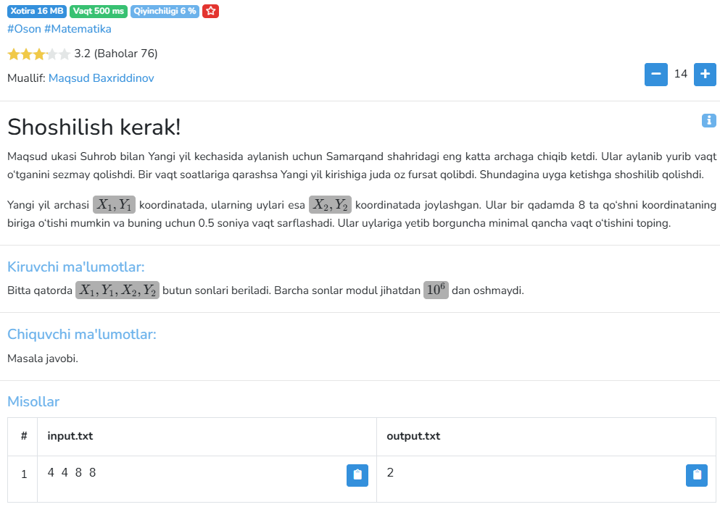
def min_time(x1, y1, x2, y2):
print(max(abs(x2 - x1), abs(y2 - y1)) * 0.5)

x1, y1, x2, y2 = map(int, input().split())

min_time(x1, y1, x2, y2)

def min_time(x1, y1, x2, y2):
dx = abs(x2 - x1)
dy = abs(y2 - y1)
steps = max(dx, dy)
if steps % 2 == 0:
return str(steps // 2)
else:
return f"{steps // 2}.5"

def main():
x1, y1, x2, y2 = map(int, input().split())
print(min_time(x1, y1, x2, y2))

if __name__ == "__main__":
main()

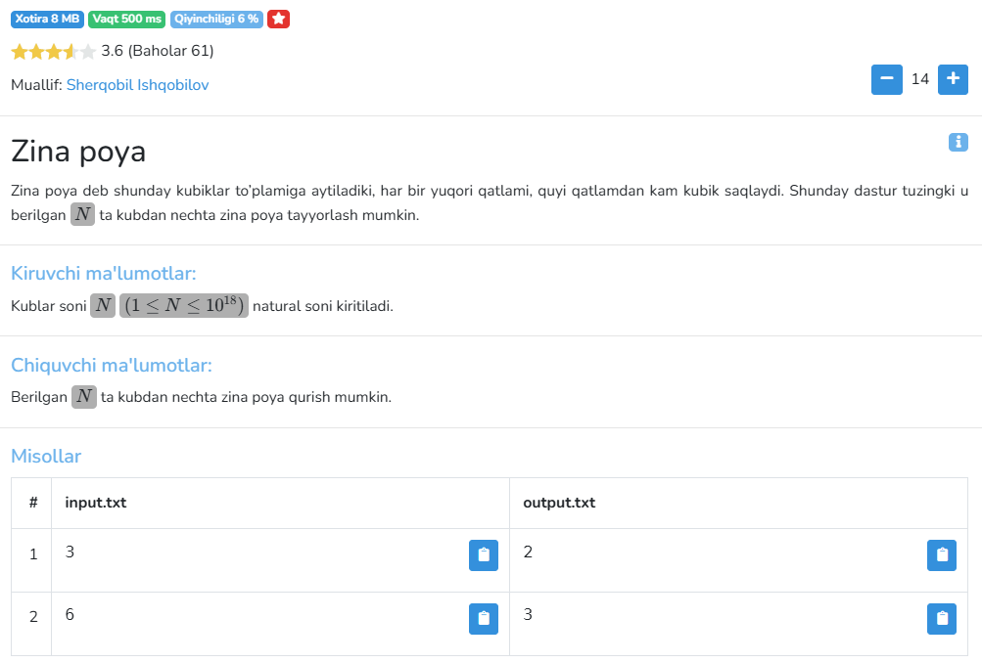
import math

def steps(n):
return int((-1 + math.sqrt(1 + 8*n)) // 2)

n = int(input())
print(steps(n))

import math

def steps(n):
return (-1 + math.isqrt(1 + 8*n)) // 2

n = int(input())
print(steps(n))

import math

def max_height(N):
return int((math.isqrt(1 + 8*N) - 1) // 2)

if __name__ == "__main__":
N = int(input().strip())
print(max_height(N))

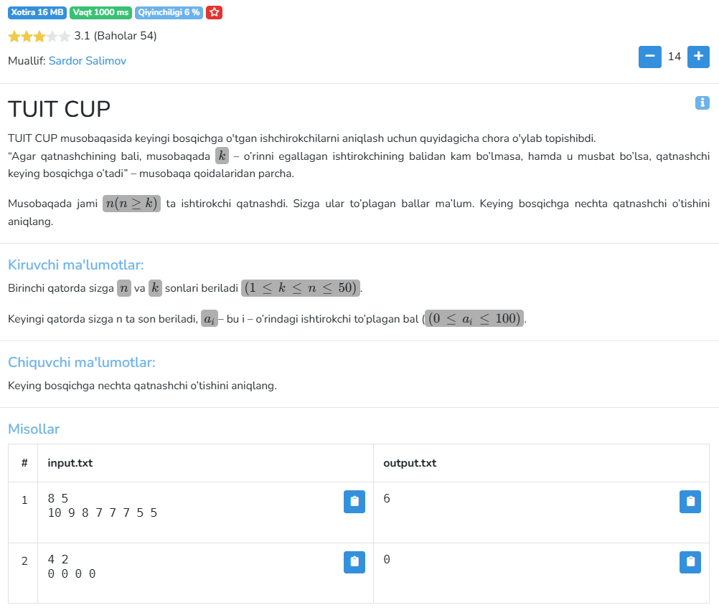
def next_step(n, k, marks):
res = 0
for mark in marks:
if mark > 0 and mark >= marks[k - 1]:
res += 1
print(res)

n, k = map(int, input().split())
marks = list(map(int, input().split()))
next_step(n, k, marks)

def next_round_count(n, k, scores):
# Ballarni kamayish tartibida joylashtiramiz
scores.sort(reverse=True)
kth = scores[k - 1]
return sum(1 for s in scores if s >= kth and s > 0)

def main():
n, k = map(int, input().split())
scores = list(map(int, input().split()))
print(next_round_count(n, k, scores))

if __name__ == "__main__":
main()

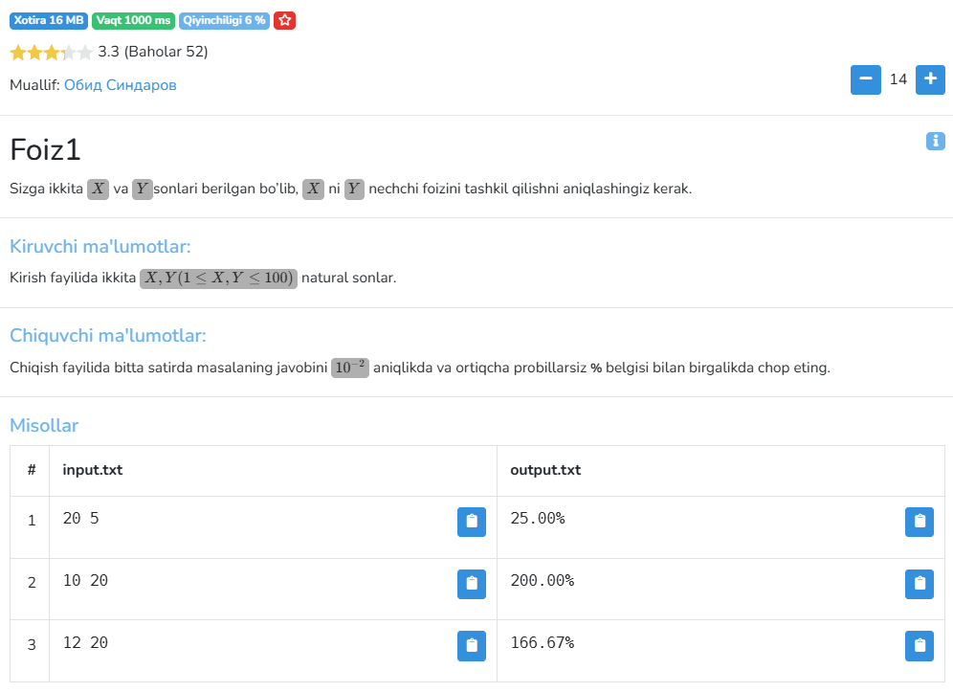
def percent_of_x(x, y):
return f"{(y / x) * 100:.2f}%"

def main():
x, y = map(int, input().split())
print(percent_of_x(x, y))

if __name__ == "__main__":
main()

def percent_of_x(x, y):
return "{:.2f}%".format(y / x * 100)

def main():
x, y = map(int, input().split())
print(percent_of_x(x, y))

if __name__ == "__main__":
main()

1. .format() funksiyasi

Umumiy tushuncha
.format() — bu string formatlash usuli. Ya’ni, matn ichida joy qoldirib ({} orqali), keyin .format() ga berilgan qiymatlarni o‘sha joylarga qo‘yish mumkin.

Asosiy sintaksis:
"matn {0} va {1}".format(qiymat1, qiymat2)
{0} → birinchi argument, {1} → ikkinchi argument.
Agar indeks yozilmasa ({}), u holda ketma-ket argumentlar joylashtiriladi.

Misollar
print("Salom, {}!".format("Dunyo"))
# Salom, Dunyo!

print("Men {} yoshdaman".format(20))
# Men 20 yoshdaman

print("{1} {0} {1}".format("olma", "anor"))
# anor olma anor

Formatlash imkoniyatlari
.format() yordamida sonlarni vergul bilan ajratish, foiz ko‘rsatish va hokazolarni boshqarish mumkin.
- Float aniqlik:
print("{:.2f}".format(12.3456))
# 12.35
- Foiz:
print("{:.2%}".format(0.25))
# 25.00%
- Kenglik berish:
print("{:10}".format("hi"))
# 'hi '
- Manfiy va musbat belgi:
print("{:+d}".format(42))
# +42
- 0 bilan to‘ldirish:
print("{:05d}".format(42))
# 00042

2. f-string (f'...' yoki F'...')

Umumiy tushuncha
f-string — Python 3.6 dan boshlab kiritilgan eng qulay va tezkor formatlash usuli. Matn oldiga f qo‘yiladi va matn ichidagi {} ichiga to‘g‘ridan-to‘g‘ri o‘zgaruvchi nomi yoki ifoda yoziladi.

Misollar
ism = "Ali"
yosh = 20
print(f"Mening ismim {ism}, yoshim {yosh}")
# Mening ismim Ali, yoshim 20

F-string ichida ifoda ishlatish mumkin:
x, y = 5, 7
print(f"{x} + {y} = {x + y}")
# 5 + 7 = 12

Formatlash imkoniyatlari
f-string .format() bilan bir xil formatlash qoidalarini qo‘llab-quvvatlaydi:
pi = 3.14159
print(f"pi = {pi:.2f}") # 2 xonali aniqlik
# pi = 3.14

foiz = 0.2567
print(f"foiz = {foiz:.1%}") # 25.7%

.format() va f-string taqqoslash
Xususiyat | .format() | f-string
Sintaksis | Uzoqroq | Juda ixcham
Tezlik | Sekinroq | Tezroq
O‘qilishi | Kamroq qulay | Oson o‘qiladi
Ifoda yozish | .format() da qiyinroq | {} ichida istalgan ifoda yozish mumkin
Qo‘llanish | Python 2 va 3 da ishlaydi | Faqat Python 3.6+

Xulosa
- Agar eski Python versiyasi ishlatilsa — .format() ishlatiladi.
- Yangi Python (3.6+) da esa f-string tavsiya qilinadi, chunki kod ixcham va tez ishlaydi.

1. Oddiy matnga o‘zgaruvchi qo‘yish
ism = "Ali"
yosh = 20

# .format() bilan
print("Mening ismim {}, yoshim {}".format(ism, yosh))

# f-string bilan
print(f"Mening ismim {ism}, yoshim {yosh}")
Har ikkisi ham chiqaradi:
Mening ismim Ali, yoshim 20

2. Aniqlik (float sonni formatlash)
pi = 3.14159265

# .format() bilan
print("pi = {:.2f}".format(pi))

# f-string bilan
print(f"pi = {pi:.2f}")
Chiqishi:
pi = 3.14

3. Foiz ko‘rinishida chiqarish
ulush = 0.2567

# .format() bilan
print("Natija = {:.1%}".format(ulush))

# f-string bilan
print(f"Natija = {ulush:.1%}")
Chiqishi:
Natija = 25.7%

4. Matn kengligini belgilash (joy tashlab yozish)
# .format() bilan
print("'{:10}'".format("salom"))

# f-string bilan
txt = "salom"
print(f"'{txt:10}'")
Chiqishi:
'salom '

5. Ifoda ichida hisoblash
x, y = 5, 7

# .format() bilan (oldin o‘zingiz hisoblab, keyin berasiz)
print("{} + {} = {}".format(x, y, x + y))

# f-string bilan (to‘g‘ridan-to‘g‘ri ifodani yozish mumkin)
print(f"{x} + {y} = {x + y}")
Har ikkisi ham chiqaradi:
5 + 7 = 12

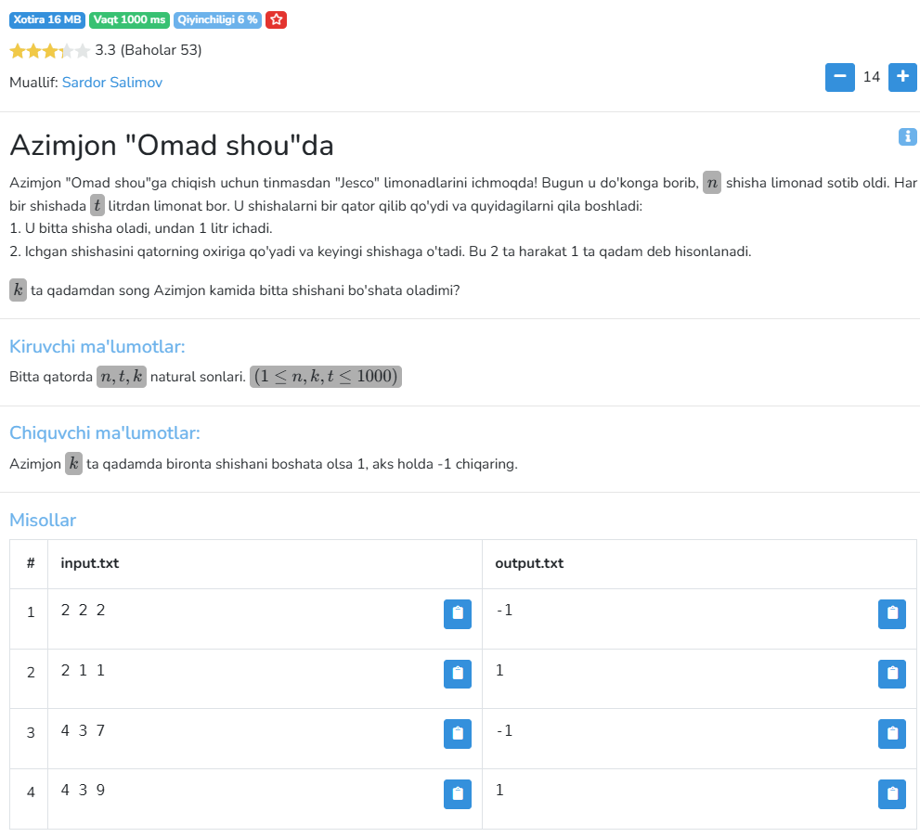
def solve(n, t, k):
if n * (t - 1) + 1 <= k:
print(1)
else :
print(-1)

n, t, k = map(int, input().split())
solve(n, t, k)

def can_empty(n, t, k):
q, r = divmod(k, n)
max_drinks = q + (1 if r > 0 else 0)
return 1 if max_drinks >= t else -1

def main():
n, t, k = map(int, input().split())
print(can_empty(n, t, k))

if __name__ == "__main__":
main()
- divmod(k, n) → (q, r) qaytaradi:
  - q = k // n — to‘liq aylanishlar soni (har bir shishadan nechta marta ichilganini kafolatlaydi).
  - r = k % n — to‘liq aylanishlardan keyin qolgan qo‘shimcha qadamlar soni.
Mazmuni: Azimjon har qadami bilan navbatdagi shishadan 1 litr ichadi (round-robin).
- Har bir shisha kamida q marta ichiladi.
- Birinchi r ta shisha yana bittadan (ya’ni q+1 marta) ichiladi.
Demak, eng ko‘p ichilgan shisha uchun ichilgan miqdor:
- q + 1 (agar r > 0 bo‘lsa),
- aks holda q.
Shuning uchun:
max_drinks = q + (1 if r > 0 else 0)
Bu — k qadamdan keyin bitta shishaga tushishi mumkin bo‘lgan maksimal litr.
Endi shartni tekshiramiz:
- Agar max_drinks >= t bo‘lsa → kamida bitta shisha bo‘shaydi → 1
- Aks holda → -1

Qisqa formulaga tengligi
max_drinks aslida ceil(k / n) ga teng:
max_drinks = (k + n - 1) // n
xuddi shu natijani beradi.

Misollardan
• n=2, t=2, k=2 → q=1, r=0 → max=1 < 2 → -1
• n=2, t=1, k=1 → q=0, r=1 → max=1 ≥ 1 → 1
• n=4, t=3, k=7 → q=1, r=3 → max=2 < 3 → -1
• n=4, t=3, k=9 → q=2, r=1 → max=3 ≥ 3 → 1

Afzalligi
- O(1) vaqt va xotira (hech qanday siklli simulyatsiya yo‘q).
- Juda ixcham va aniq.

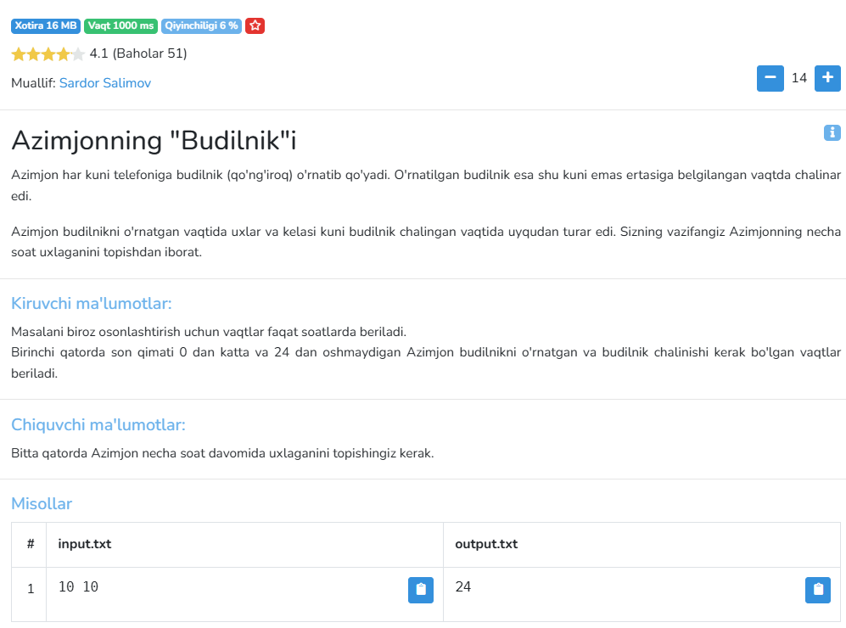
def solve(h1:int, h2:int)->int:
print(24 + h2 - h1)

h1, h2 = map(int, input().split())
solve(h1, h2)

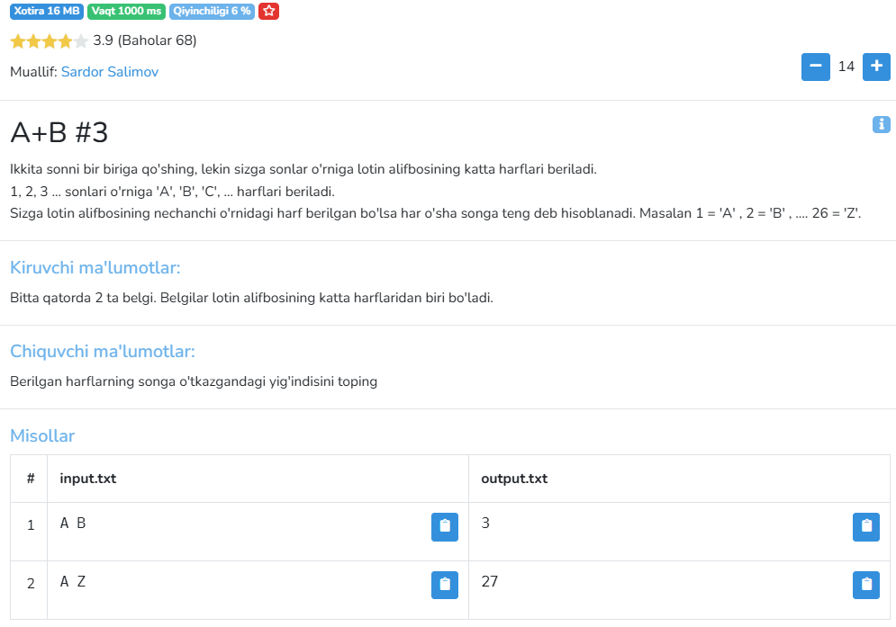
def sumLetters(letter1, letter2):
return ord(letter1) - ord('A') + ord(letter2) - ord('A') + 2

letter1, letter2 = input().split()
print(sumLetters(letter1, letter2))

def letters_sum(a: str, b: str) -> int:
# 'A' → 1, 'B' → 2, ... 'Z' → 26
return (ord(a) - ord('A') + 1) + (ord(b) - ord('A') + 1)

# Kiritish (masalan input.txt'dan o'qish o‘rniga, oddiy input funksiyasi bilan)
x, y = input().split()
print(letters_sum(x, y))

